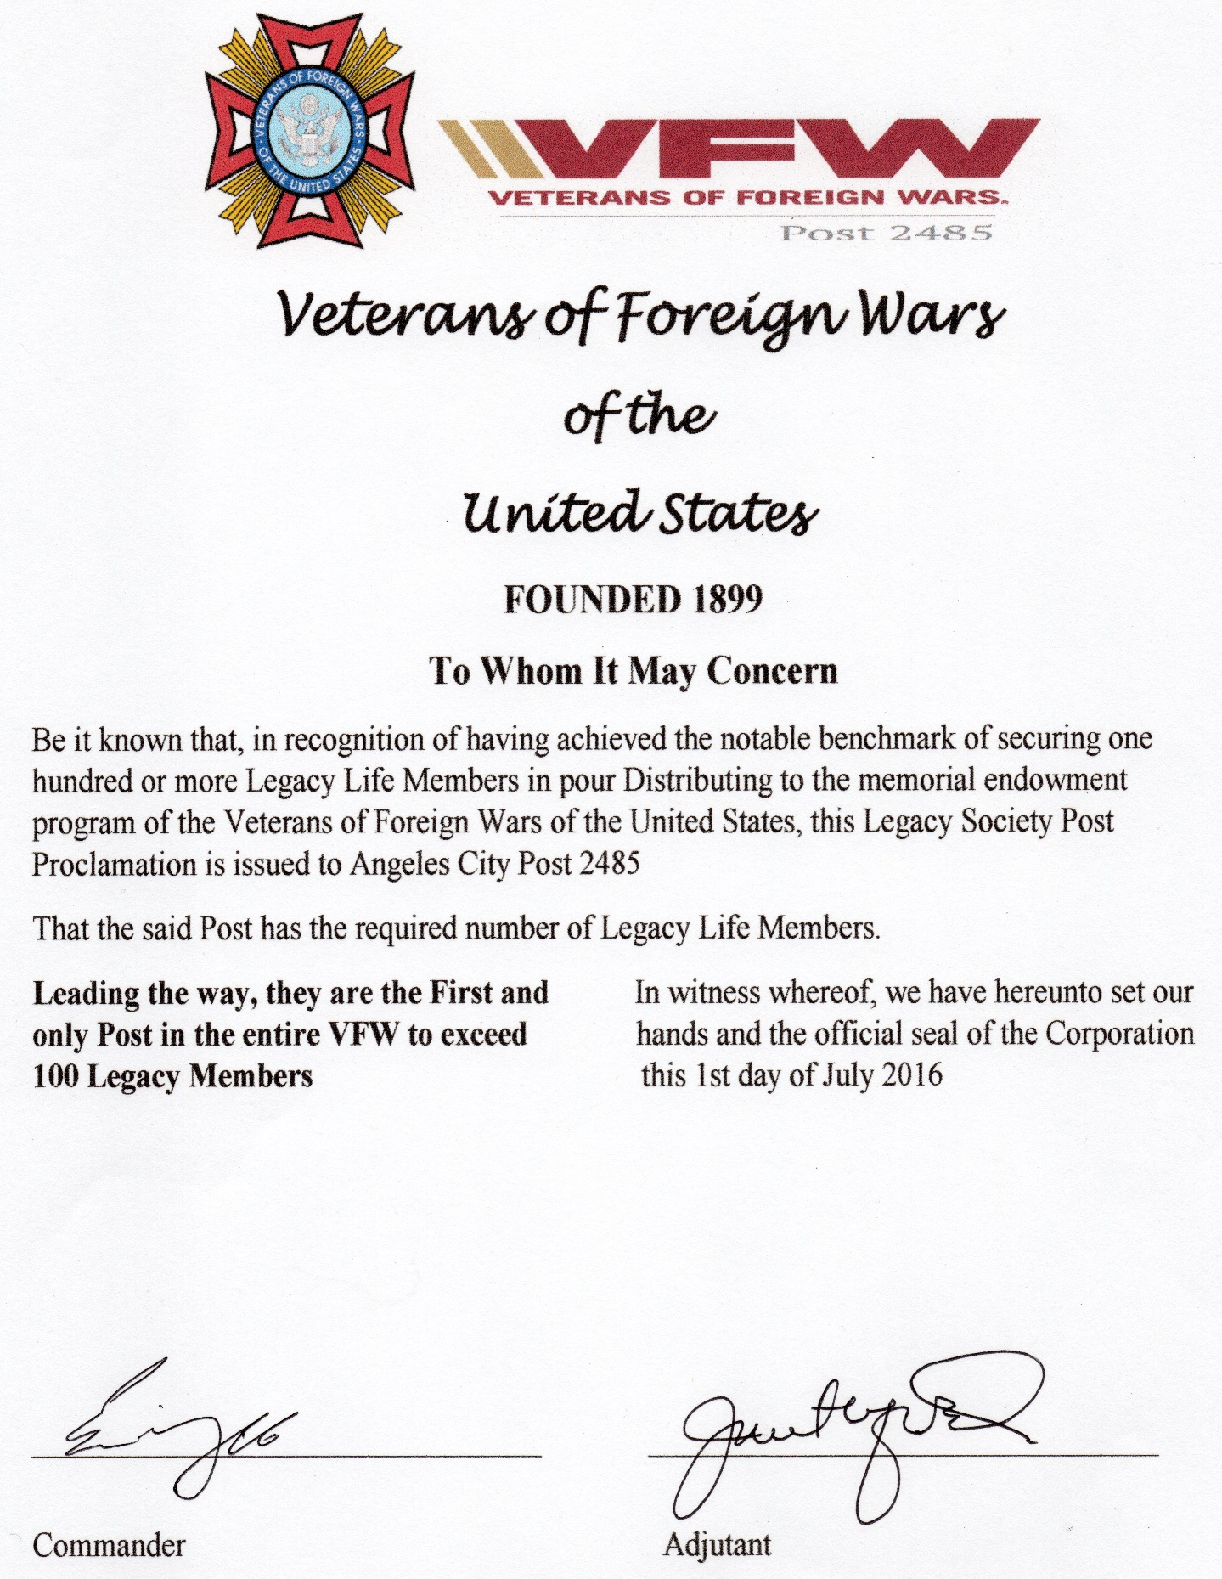

Last Name First Name Legacy Last Name First Name Legacy
Adams John Q Gold Adams William L. Silver
Aldrich Thomas G. Gold Ameccci* Ernest N. Gold
Andrejcik Christopher Bronze Ballaro Donald P. Gold
Ballos Honorito A. Bronze Bannister Warren E. Gold
Barsy* Dale A. Gold Bragdon* Emil E. Gold
Brown* Walter T. Gold Brown* Gerald T. Gold
Burke Carl D. Gold Burrus* Ronald Gold
Byrd Grady E. Gold Carsley* Joseph Gold
Chaplin Gerald F. Gold Ciriello Richard J. Gold
Clark Jr. Willis Gold Cobb* Lee Gold
Collins James E. Gold Collins Chrsitopher Gold
Compton Michael T. Gold Conaty Donald B. Gold
Corey Clifton S. Bronze Corni Richard A. Gold
Crist Jonathan L. Gold Crowe David T. Bronze
Crutchfield Richard Bronze Davis Paul E. Gold
Decker Walter O Gold Delves Robert L. Gold
Devore Michael D Bronze Dibble John C Gold
Dietz Jack B Gold Donaldson Lafayette Bronze
Dwyer Charles J Gold Elliott Thomas I Gold
Eredia Jesse G Gold Essary Randy L. Gold
Fallon III Joseph B Gold Farrow Roosevelt Gold
Flaherty* Paul F. Gold Frees III Williams A Gold
Gage Herbert A Bronze Gallagher Thomas J Gold
Gamache Donald Bronze Gasperson Paul T Gold
Gebhardt Steven C Gold Geisler Larry E Gold
Gilbert John Gold Gillich Jr James W Gold
Gladding Matthew D Bronze Grimm Anthony P Bronze

Last Name First Name Legacy Last Name First Name Legacy
Grubbs William R Gold Harcourt Micah N Bronze
Harriamn Douglas Gold Harris Carl A Gold
Harvey Ronnie E Gold Hawkins* Brian H Gold
Higginbottom Craig Gold Hoffman Charles C Bronze
Hoggs James D Gold Howard* Walter E Gold
Hruzek Patrick H Gold Hubert* John K Gold
Istvan John J Gold Jernigan Eddie L Gold
Johnson* Lowell E Gold Jones* William Gold
Jones Egbert Bronze Kempski Michael J Gold
Kenny* Edward W Gold Labenne Edgar I Gold
Large* Russell D Gold Lask Vernon C Silver
Liebhaber Ralph F Bronze Limson Gonzalo Y Gold
Lyon* William Gold Lyons* Edward Gold
Macon* Norman Gold Marr Warren W. Gold
Marsh John A Gold Marshall Jr* John Gold
Mason David T Gold Mayberry John T Gold
McCallum Malcolm M Gold McCoy Arthur D. Gold
McFadden Carl E. Gold McGuire Buddy W. Gold
McKelvie* Clayton L Gold Mcneish Timothy Gold
Metherell David L Gold Miller Bryan S Gold
Miller Peter J Gold Mitchell* Albert R Gold
Montgomery* James E. Gold Morgenthal* Paul O Gold
Napsey Michael Bronze Nava Guadalupe E. Bronze
Nelson* Eric D Gold Palomino Refugio Gold
Parker Robert E. Gold Patch Dennis C. Gold
Pennell Sr* Benjamin N Gold Perdew Edward L Gold
Piechocky Steven J Gold Portis Jonathan N Gold

Last Name First Name Legacy Last Name First Name Legacy
Prinz* Gerald H Gold Radel Lawrence A Gold
Rader* Larry B Gold Reedy William J Gold
Reveille* John R Gold Rubio Jr Eduardo Gold
Sachkar Leon S Gold Schaefer* Kenneth W Gold
Scholoff* Donald F Gold Schulze Donald Bronze
Sculley Michael P Bronze Simshaw Lyle A Gold
Smith* Fred E Gold Smith Norman G Gold
Starr Sr Fred R Gold Stegall Lendall Bronze
Stone* Gary D Bronze Stone Roger C Gold
Tanner Mark E Gold Teets Ronald D Gold
Tevis* Frank C Gold Thomas* Tom Gold
Travers Sr Linus B Gold Turner* Archie Gold
Viands Charles Gold Wagner* Richard M Gold
Westrip Jr Charles W Bronze Williams Mark O Silver
Wilsey Clifton W Gold Wilsey Jr CliftonW Gold
Winge III Gaylord H Gold Wright Dennis L Gold
Wyffels David D Gold Zaher* Robert W Gold
Zarriello Eric V Gold

